Web Design and Development

4COSC011W

Report

Author: Sri Harish Murugesu

Student ID:

W1809920

Group Number: B1

Student Role: 3

Link(s) to WebSite

URL:

* <https://w1809920.users.ecs.westminster.ac.uk/AboutUs.html>
* <https://w1809920.users.ecs.westminster.ac.uk/Quiz.html>
* <https://w1809920.users.ecs.westminster.ac.uk/PageEditor.html>

1. Introduction 2

2. Technical Discussion 3

• Presentation Page 3

• Buy products 3

Student 2: 3

• Query Form 3

• Quiz 3

• Thumbnail Images 3

Student details 4

Design Part 6

Quiz Part 10

JavaScript part 12

Design Part 15

3. Janet 17

References 17

Appendices 18

Appendix A: Code 18

Appendix B: Screenshots 32

Appendix C: Individual Statement 34

# Introduction

Section guidelines: List of the team members, allocation of tasks (student 1 to 4), and topic of the website.

* Raahul Ganesh – Student 1
* Mayur Arvindh – Student 2
* Sri Harish Murugesu – Student 3
* Maathusan Thirunayansampthan – Student

# Technical Discussion

*Max 1000 words*

Section guidelines:

* Discuss the development of the tasks that **you were allocated**. This technical discussion must include the approach taken, and explanations of how the required functionality was implemented. Illustrate your explanation with code snippets and screenshots. Also explain the difficulties you faced and how you solved them.
* Illustrate your technical discussion with screenshots and code samples.
* **Discuss only the following tasks that you were allocated. State if any of your allocated tasks were not completed.**

Student 1:

## Presentation Page

## Buy products

## Student 2:

* Main Page &External CSS

## Query Form

Student 3:

## Quiz

* Student details

Student 4:

* Diagram (SVG)

## Thumbnail Images

(All students) Page Editor Page

Technical Discussion

I did the part to make a site about my team members details and one minute quiz with 10 questions about sports topic.

# Student details

This is my student details page looks like.

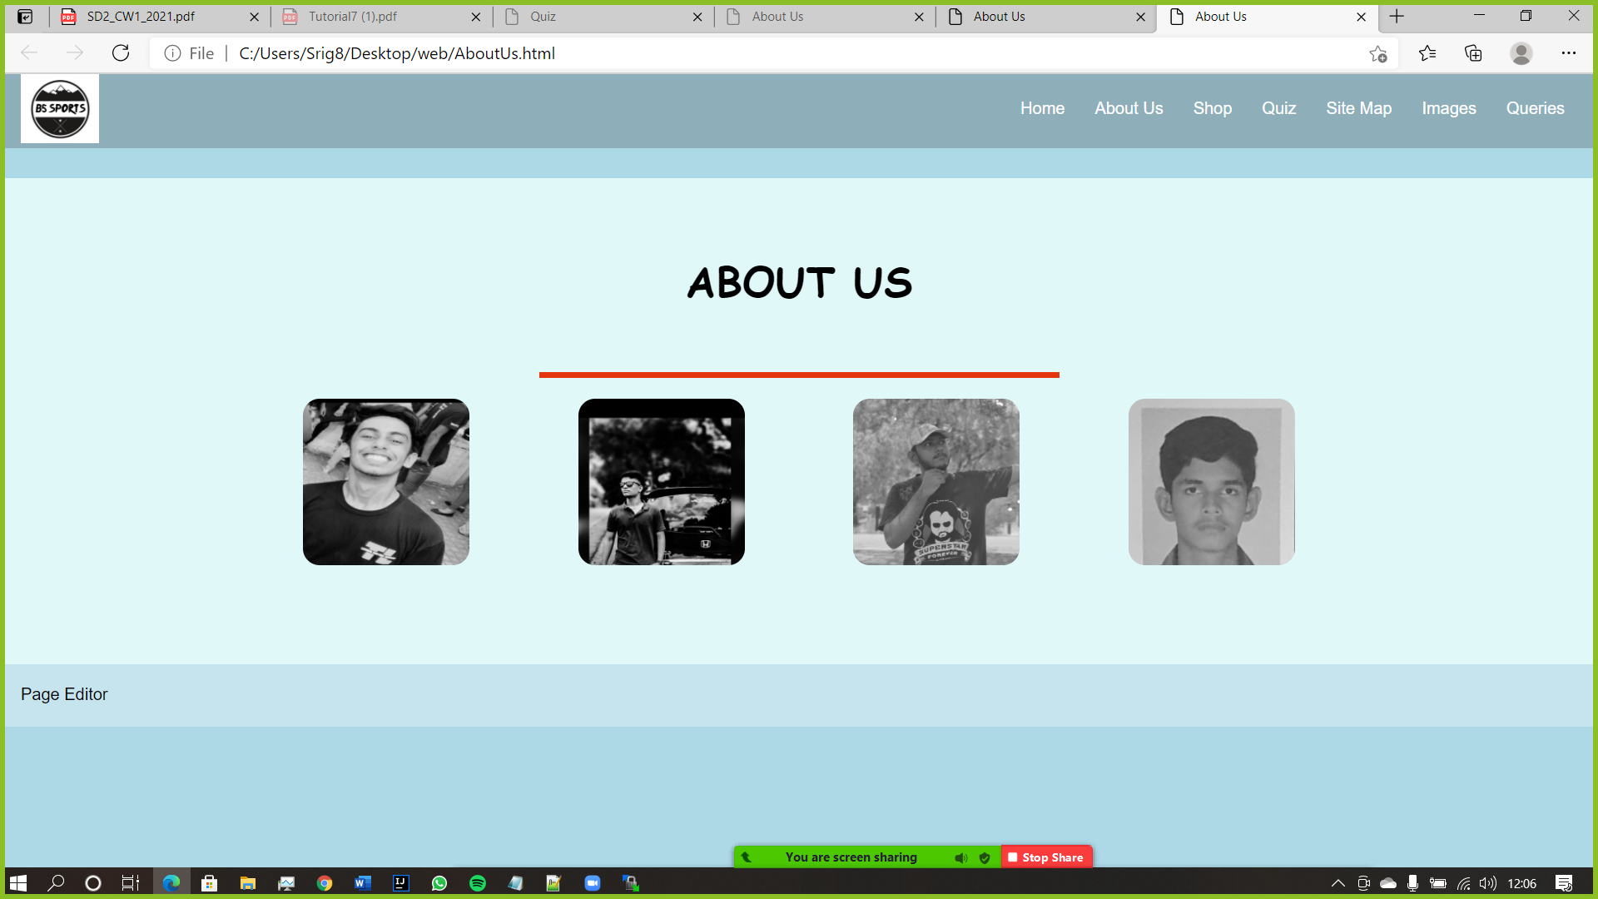

Once the User clicks on the picture it will turn into normal color and shows you detail as below.

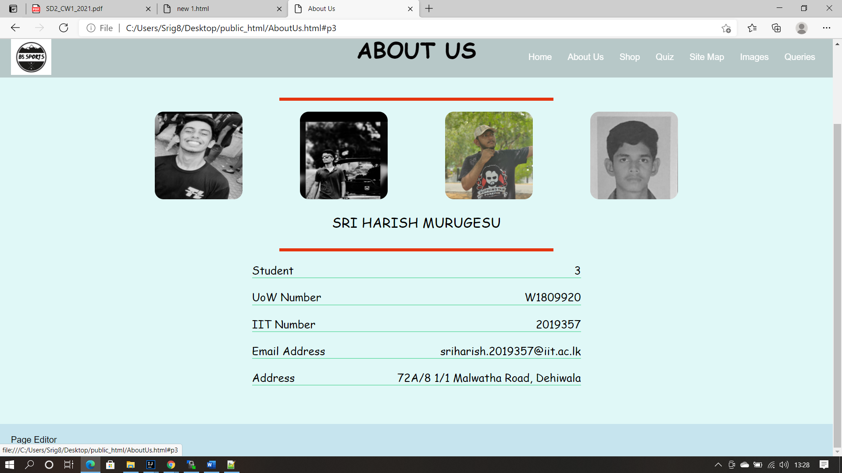

I used a div classes to make the photos look box and stylish and made the color greyscale so when the user moves the cursor towards the photo the photo will turn into default color as before.

<a href="#p3"><img src="photos/p3.jpg" alt="pic3" width="200" height="200" ></a>

This is the link for student 3 where I used the photo as a link to make the user click once to show the details down below.

<div class="section" id="p3">

<span class="name">Sri Harish Murugesu</span>

<span class="border"></span>

<ul>

<li class="name-listing">

<p>Student </p>

<p>3</p>

</li>

<li class="name-listing">

<p>UoW Number </p>

<p>W1809920</p>

</li>

<li class="name-listing">

<p>IIT Number </p>

<p>2019357</p>

</li>

<li class="name-listing">

<p>Email Address</p>

<p>sriharish.2019357@iit.ac.lk</p>

</li>

<li class="name-listing">

<p>Address</p>

<p>72A/8 1/1 Malwatha Road, Dehiwala</p>

</li>

</ul>

</div>

In this part I created a div class named section and used span class to create a border o separate the details and photos without sticking together. And I created a list class named “name-listing” to design the parts to bring in to center once the user clicks on it. Creating a section for every student is because when the user clicks on the photo it should show only his details and not others information.

## Design Part

*{

padding:0px;

margin:0px;

box-sizing: border-box;

}

.header_aboutUs{

width: 100%;

height: 100px;

}

/* logo height and width */

.picture{

width: 5%;

height:5%;

}

/* the top menu */

.navbar{

width:100%;

padding:20px;

position:fixed;

top:0px;

transition:0.5s;

background-color: rgba(18, 11, 11, 0.2);

padding-bottom:0;

padding-top:0;

}

.navbar .navbar-right ul li{

list-style-type:none;

display:inline-block;

}

.navbar .navbar-right ul li a{

padding:10px 12px;

font-family: Calbri, sans-serif;

cursor:pointer;

border-radius:10px;

color:white;

text-decoration:none;

}

.navbar .navbar-right ul li a:hover{

background-color: rgba(255, 255, 255, 0.5);

transition-duration: 0.5s;

transition-timing-function: ease-in-out;

}

.navbar .navbar-right{

float:right;

padding-top:20px;

}

/* end of menu*/

/*start of about us*/

.team{

overflow: hidden;

text-align: center;

background: #E0F8F7;

padding: 70px;

}

.team h1{

text-transform: uppercase;

margin-bottom: 60px;

color: black;

font-size: 40px;

}

.border{

display:block;

margin: auto;

width: 500px;

height: 6px;

background: #E5350F;

margin-bottom: 20px;

}

.ps{

margin-bottom: 20px;

}

.ps a{

display: inline-block;

margin: 0 50px;

width: 160px;

height: 160px;

overflow: hidden;

border-radius: 10%;

}

.ps a img{

width: 100%;

filter: grayscale(100%);

transition: 0.4s all;

}

.ps a:hover > img{

filter: none;

}

.section{

width: 600px;

margin: auto;

font-size: 20px;

color: black;

text-align: justify;

height: 0;

overflow: hidden;

}

.section:target{

height: auto;

}

.name{

display: block;

margin-bottom: 30px;

text-align: center;

text-transform: uppercase;

font-size: 25px;

}

.section li.name-listing {

display: flex;

justify-content: space-between;

margin-top: 20px;

border-bottom: 1px solid rgba(35, 203, 119, 0.74);

}

/* start of footer*/

.footer {

font-family: Arial, sans-serif;

padding-top:20px;

background-color:rgba(255, 255, 255, 0.3);

width:100%;

height:60px;

bottom:0;

}

.footer_fontSizechange{

align-items:center;

justify-content:center;

width: auto; /*can be in percentage also.*/

height: auto;

margin: 0 auto;

padding-left:20px;

padding-bottom: 10px;

padding-left:20px;

position: relative;

}

.footer a{

padding:10px 20px;

cursor:pointer;

color: black;

border-radius:10px;

text-decoration:none;

}

.footer a:hover{

background-color: rgba(255, 255, 255, 0.3);

transition-duration: 0.5s;

transition-timing-function: ease-in-out;

}

To make the photos look more attractive in a box shape I used border radius to adjust and made the photos greyscale where once the user moves the cursor to the photo it will reveal its original colour. And displaying the students details in the justify and changed every text format into uppercase and setting a border to separate the margins without the photos and the details touch each other. And other technical stuff such as font sizes and list spacing and colour of the backgrounds and font styles and adjusting the height to auto. And making margin spaces to separate each border so that the user will be able to see it nice manner.

Mostly I used div functions in order to flex the photos and of the students and made them into hover and made the width 600px in order to make the user clearly visualize more easily,

making the colour black in order to match the background colour which is light blue.

## Quiz Part

Below you will see my quiz page:

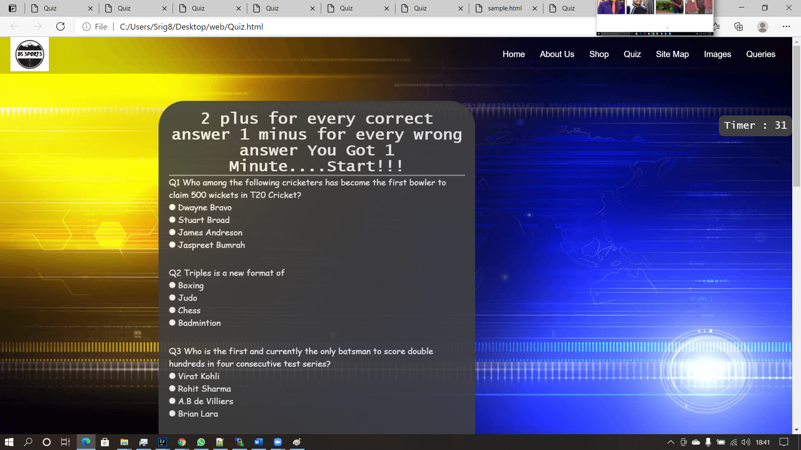

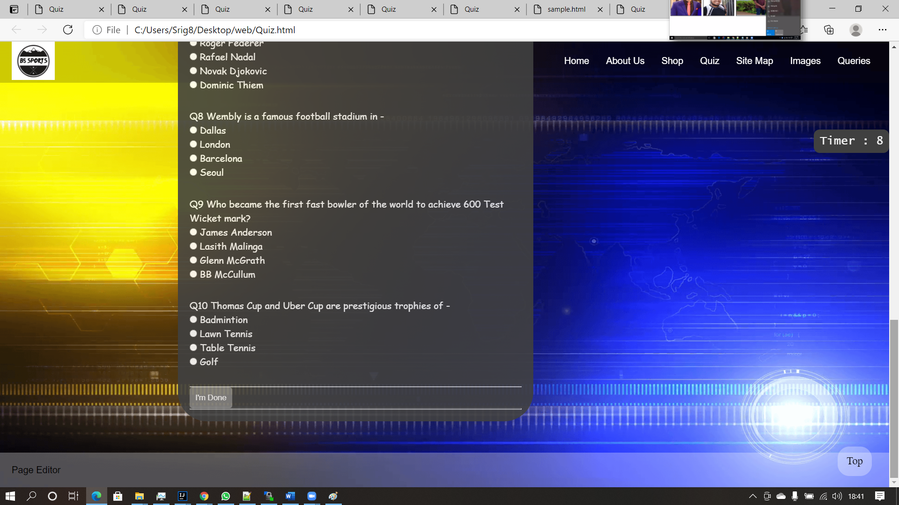

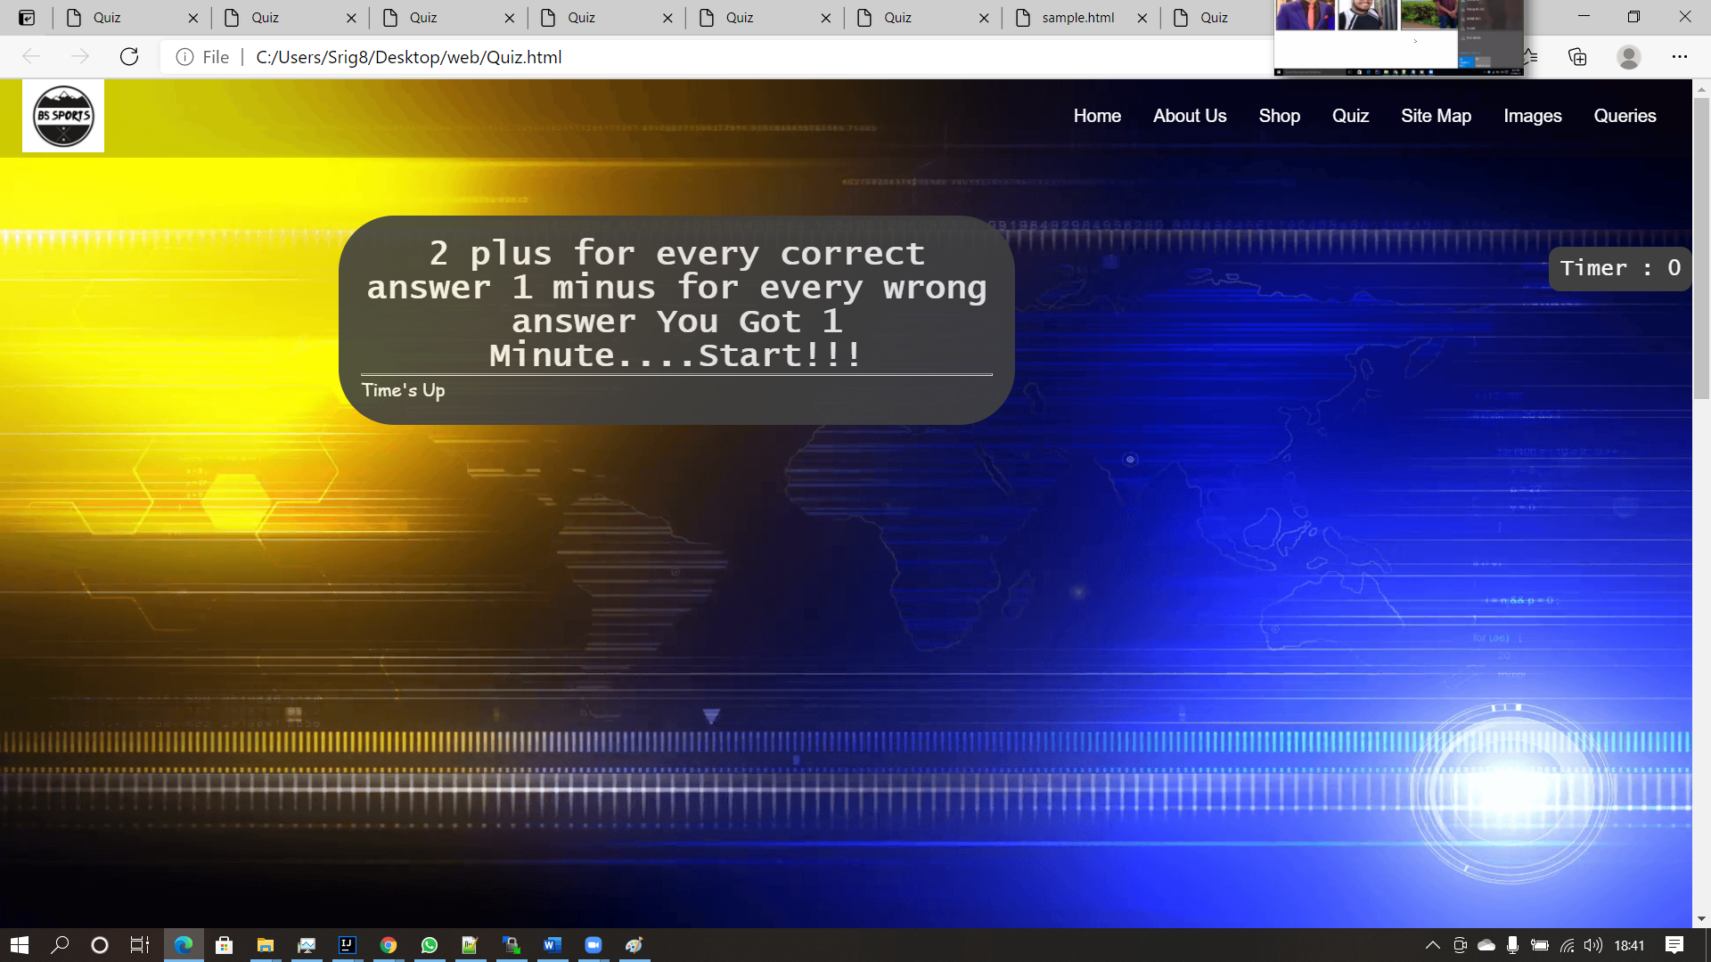

This where I created my quiz making the user understand in beginning of the that 2 marks for each correct answer and 1 mark for each wrong answer and the user has only one minute once the timer runs out the questions will be hidden and printing Time’s Up as the output. And mostly the padding was created in order adjust the questions inside the padding to look small and more visible for the user to answer the questions. And the main purpose of all quiz questions being displayed is because it makes the user to easily check back the question in case if he forgets to click on it.

<p>Q1 Who among the following cricketers has become the first bowler to claim 500 wickets in T20 Cricket?</p>

<input type="radio" name="q1" value="Dwayne Bravo"><a> Dwayne Bravo</a><br>

<input type="radio" name="q1" value="Stuart Broad"><a> Stuart Broad</a><br>

<input type="radio" name="q1" value="James Andreson"><a> James Andreson</a><br>

<input type="radio" name="q1" value="Jaspreet Bumrah"><a> Jaspreet Bumrah</a><br>

<div id="answer1" style="height: 30px; width: 500px;"> </div>

The questions were made using radio buttons assigning the name as q1 and creating a link on each answer so that the user can see the answer in a more colourful way.

<div id= "time" class="time" >

<p id="timer"> </p>

</div>

The above code is for the timer where the timer will able to see for user to show the seconds remaining to complete the quiz further will be spoken in design part. And this basically making the time more vibrant and the user should know how much time left and using class as time to make the design part stylish looking. Using timer to as ID in order to call the function in java script to make the time reduce and show the user he is running out of time.

## JavaScript part

<!--Timer calculation-->

var timer;

var sec = 60;

var sec2;

window.onload = function timecount(){

timer = setInterval(function(){

sec--;

if (sec == 0){

clearTimeout(timer);

document.getElementById("box").innerHTML = "Time's Up"

}

document.getElementById("timer").innerHTML = "Timer " + " : " + sec ;

},1000);

}

The timer part was created to count seconds to make the quiz end once the timer runs out.

I created a variable called timer, sec and sec2 making the sec equal to 60 initial timer, which is the allocated time for the user to do the quiz. And created a function called timecount to implement the code to show the time. And by reducing the sec if the sec hits 0 it should clear out the timer and should input that the timer is a up inside the question padding. And in the side the I made it horizontal and fixed so when the user goes down he will able to see the timer. And by showing the timer and sec limiting it to 1000.

<!--Answer validation-->

function check(){

clearTimeout(timer);

var ans1Arr = document.getElementsByName("q1");

var ans2Arr = document.getElementsByName("q2");

var ans3Arr = document.getElementsByName("q3");

var ans4Arr = document.getElementsByName("q4");

var ans5Arr = document.getElementsByName("q5");

var ans6Arr = document.getElementsByName("q6");

var ans7Arr = document.getElementsByName("q7");

var ans8Arr = document.getElementsByName("q8");

var ans9Arr = document.getElementsByName("q9");

var ans10Arr = document.getElementsByName("q10");

var correct = 0;

var ans1Select = " "; var ans2Select = " "; var ans3Select = " "; var ans4Select = " "; var ans5Select = " ";

var ans6Select = " "; var ans7Select = " "; var ans8Select = " "; var ans9Select = " "; var ans10Select = " ";

//Question1

for (var i=0; i< ans1Arr.length;i++){

if (ans1Arr[i].checked){

ans1Select = ans1Arr[i].value;

break;

}

}

if (ans1Select == " ") {

document.getElementById("answer1").innerHTML = "You did not select an answer" ;

document.getElementById("answer1").style.color = "red";

}

else if(ans1Select == "Dwayne Bravo") {

document.getElementById("answer1").innerHTML = "Correct answer!!!" ;

correct +=2;

document.getElementById("answer1").style.color = "green";

}

else {

document.getElementById("answer1").innerHTML = "Wrong Answer! Correct Answer is Dwayne Bravo." ;

correct--;

document.getElementById("answer1").style.color = "red";

}

I created a function “check” where once the user clicks the button “I’m done” the answers should be displayed with the marks and how long it took to complete with colour changing according to the marks that the user has got with a message saying how he performed.

<input id= "button2" type="button" value="I'm Done" onclick="check();">

I created an array to store the answer for the question and another set of variables to declare the selected answers accordingly to user clicks as the final answer and correct variable to get the correct answers from the users and display the results after he clicks “I’m Done” button.

I used for loop and made a variable i to check the length of the array which is q1 and incrementing the i less than ans1Arr length. And using if condition to check the ans1Arr in i is true or false, and using another variable named ans1Select to equally assign the value of the an1Arr to ans1Select.

And rest using ans1Select as the selection option I have used if condition to check if the ans1Select equals to the answer I assign, if the user doesn’t click on the radio button it will print “you did not select an answer” in red colour, and if the user clicks on a wrong button it will print “your answer is wrong” and the correct answer will be displayed in red colour, if he clicks on the correct answer it will print “correct answer” with the colour in green.

if (correct<0){

correct=0;

}

//the message according to the marks obtained

var messages = ["Well Done!!!","Nicely Done!!!", "Good job!!!", "It's Alright Try Again..."];

//Change background color according to the marks obtained

var score;

if (correct ==20) {

score = 0;

{

document.getElementById("quiz").style.backgroundColor = "#3cb371";

}

}

else if (correct >14) {

score = 1;

{

document.getElementById("quiz").style.backgroundColor = "#3cb371";

}

}

else if (correct > 8) {

score = 2;

{

document.getElementById("quiz").style.backgroundColor = "#ffa500";

}

}

else {

score = 3;

{

document.getElementById("quiz").style.backgroundColor = "#800000";

}

}

/* Remaining timer to display after the quiz finishes to display results */

sec2 = 60 - sec;

document.getElementById("after_submit").style.visibility = "visible";

document.getElementById("number_correct").innerHTML = "You scored " + correct + "/20."+ " It took you " + sec2 + " Seconds to complete.";

document.getElementById("message").innerHTML = messages[score];

After the answers have been clicked by the user it will check the answers from 0 to 20 and according to the correct answers the user gets it will output the answer and the how long it took to complete by setting a variable named se2, and with a small message on how the user has performed. If the user gets less than 8 it will print a message saying “It’s alright try again” and the background of padding will change to red and yellow for more than 8, green for more than 14.

## Design Part

/*resposive scroll up button*/

#myBtn {

display:none;

position:fixed;

bottom:20px;

right:30px;

z-index:99;

font-family:Cabin Sketch;

cursor: pointer;

font-size:18px;

font-weight:body;

border:none;

outline:none;

background-color:rgba(255,255,255,0.3);

color:black;

padding:15px;

border-radius:20px;

}

/* timer */

#box{

line-height:1.5em;

}

.header_quiz{

width: 100%;

height: 100px;

}

.questions{

width:100%;

height:1900px;

}

.questions #time {

border-radius: 10px;

position:fixed;

right:0;

top:150px;

padding: 10px;

background:#404040;

font-size: 20px;

color: WhiteSmoke ;

text-align: center;

font-family: Lucida Console, Monospace;

}

/* heading */

.questions #Q{

font-size: 30px;

color: WhiteSmoke ;

font-family: Lucida Console, Monospace;

text-align: center;

}

/* container for the quiz */

.questions #quiz {

width: 40%;

margin-left: 20%;

border-radius: 50px;

padding: 20px 20px 20px;

background: #404040;

color: WhiteSmoke ;

opacity: 0.9;

}

/* buttons */

.questions #button2 {

border: none;

border-radius: 5px;

padding: 10px;

background: #808080;

color: WhiteSmoke ;

}

.questions #button2:hover {

background: #595959;

color: WhiteSmoke;

cursor: pointer;

}

.questions a:hover{

background: #737373;

border-radius:40%;

}

I have styled mostly on the buttons and colour paddings on the questions and the border cover of the questions in total, and making the buttons more visible for the users to see it more visually while answering the questions. And designing the timer box to fixed and constant line so when the user scrolls down the user will be still able to see it. And similar to the about us part I have used margins and border radius to adjust and give spacing to the questions and answer without colliding each other. And padding them to 4 * 20px to adjust the corners and make the quiz container more stylish. And I have used white-smoke colour to make the design layer of the quiz questions and the timer more beautiful.

# Janet

Section guidelines: Explain how your web site complied with Janet Regulations, [Janet Policies and Legal Requirements](https://community.jisc.ac.uk/library/janet-services-documentation/janet-policies-and-legal-requirements). Max 200 words

I have followed all the guidelines of protecting the network data and I did not include unwanted images or exploitation of codes or misused them. I did not attempt to take others work or hack websites in order to make it to my advantage. I have referenced the secured sites and used my own knowledge to develop the codes.

# References

Provide references to resources you have used.

Tutorialspoint.com. 2021. *Javascript Tutorial - Tutorialspoint*. [online] Available at: <https://www.tutorialspoint.com/javascript/index.htm> [Accessed 12 March 2021].

W3schools.com. 2021. *W3Schools Online Web Tutorials*. [online] Available at: <https://www.w3schools.com/> [Accessed 12 March 2021].

Google.com. 2021. *Google Image Result for https://wallpapercave.com/wp/wp2940431.png*. [online] Available at: <https://www.google.com/imgres?imgurl=https%3A%2F%2Fwallpapercave.com%2Fwp%2Fwp2940431.png&imgrefurl=https%3A%2F%2Fwallpapercave.com%2Fsports-background&tbnid=Rnb_nXraQO-C3M&vet=12ahUKEwjPp4-tzcXvAhWTYH0KHVUUBEIQMygKegUIARDhAQ..i&docid=7d-qunPvpIORCM&w=1920&h=1080&q=background%20images%20for%20sports&ved=2ahUKEwjPp4-tzcXvAhWTYH0KHVUUBEIQMygKegUIARDhAQ> [Accessed 23 March 2021].

# Appendices

## Appendix A: Code

Provide a full listing of your files, with well indented and commented code in the following format:

Filename Quiz.html

Code

<!DOCTYPE html>

<html>

<head>

<meta charset="UTF-8">

<title>Quiz</title>

<link rel="stylesheet" type="text/css" href="CSS/stylequiz.css">

<link rel="stylesheet" type="text/css" href="CSS/styles.css">

<style>

body{

background-image: url('photos/bimage.png');

background-repeat: no-repeat;

background-attachment: fixed;

background-size: 100% 100%;

font-family: Comic Sans MS,Comic Sans;

font-size: 16px;

}

</style>

</head>

<body>

<button onclick="topFunction()" id="myBtn" title="Go to top">Top</button>

<div class="header_aboutUs">

<div class="navbar">

<img src="photos/mylogo.jpg" alt="logo" class="picture" >

<div class="navbar-right">

<ul>

<li><a href="MainPage.html">Home</a></li>

<li><a href="AboutUs.html">About Us</a></li>

<li><a href="Shop.html">Shop</a></li>

<li><a href="Quiz.html">Quiz</a></li>

<li><a href="sitemap.html">Site Map</a></li>

<li><a href="gallery.html">Images</a></li>

<li><a href="queries.html">Queries</a></li>

</ul>

</div>

</div>

</div>

<div class="questions">

<!-- questions padding-->

<!-- timer display -->

<div id= "time" class="time" >

<p id="timer"> </p>

</div>

<br>

<form id= "quiz" name="quiz" >

<h1 id="Q">2 plus for every correct answer

1 minus for every wrong answer You Got 1 Minute....Start!!!</h1>

<hr>

<div id = "box">

<!--questions and answers-->

<p>Q1 Who among the following cricketers has become the first bowler to claim 500 wickets in T20 Cricket?</p>

<input type="radio" name="q1" value="Dwayne Bravo"><a> Dwayne Bravo</a><br>

<input type="radio" name="q1" value="Stuart Broad"><a> Stuart Broad</a><br>

<input type="radio" name="q1" value="James Andreson"><a> James Andreson</a><br>

<input type="radio" name="q1" value="Jaspreet Bumrah"><a> Jaspreet Bumrah</a><br>

<div id="answer1" style="height: 30px; width: 500px;"> </div>

<p>Q2 Triples is a new format of</p>

<input type="radio" name="q2" value="Boxing"><a> Boxing</a><br>

<input type="radio" name="q2" value="Judo"><a> Judo</a><br>

<input type="radio" name="q2" value="Chess"><a> Chess</a><br>

<input type="radio" name="q2" value="Badmintion"><a> Badmintion</a><br>

<div id="answer2" style="height: 30px; width: 500px;"> </div>

<p>Q3 Who is the first and currently the only batsman to score double hundreds in four consecutive test series?</p>

<input type="radio" name="q3" value="Virat Kohli"><a> Virat Kohli</a><br>

<input type="radio" name="q3" value="Rohit Sharma"><a> Rohit Sharma</a><br>

<input type="radio" name="q3" value="A.B de Villiers"><a> A.B de Villiers</a><br>

<input type="radio" name="q3" value="Brian Lara"><a> Brian Lara</a><br>

<div id="answer3" style="height: 30px; width: 500px;"> </div>

<p>Q4 Wanamaker Trophy is associated with the game of -</p>

<input type="radio" name="q4" value="Chess"><a> Chess</a><br>

<input type="radio" name="q4" value="Squash"><a> Squash</a><br>

<input type="radio" name="q4" value="Golf"><a> Golf</a><br>

<input type="radio" name="q4" value="Skating"><a> Skating</a><br>

<div id="answer4" style="height: 30px; width: 500px;"> </div>

<p>Q5 Where the Winter Olympic Games 2022 will be organized?</p>

<input type="radio" name="q5" value="Pyeong Chang, South Korea"><a> Pyeong Chang, South Korea</a><br>

<input type="radio" name="q5" value="Vancouver, Canada"><a> Vancouver, Canada</a><br>

<input type="radio" name="q5" value="Sochi, Russia"><a> Sochi, Russia</a><br>

<input type="radio" name="q5" value="Beijing, China"><a> Beijing, China</a><br>

<div id="answer5" style="height: 30px; width: 500px;"> </div>

<p>Q6 Which international sports federation has approved a proposal to ensure gender representation in its Council?</p>

<input type="radio" name="q6" value="WA"><a> WA</a><br>

<input type="radio" name="q6" value="BWF"><a> BWF</a><br>

<input type="radio" name="q6" value="FIH"><a> FIH</a><br>

<input type="radio" name="q6" value="ISSF"><a> ISSF</a><br>

<div id="answer6" style="height: 30px; width: 500px;"> </div>

<p>Q7 Who among the following Tennis Player has won the US Open Men's Title 2020?</p>

<input type="radio" name="q7" value="Roger Federer"><a> Roger Federer</a><br>

<input type="radio" name="q7" value="Rafael Nadal"><a> Rafael Nadal</a><br>

<input type="radio" name="q7" value="Novak Djokovic"><a> Novak Djokovic</a><br>

<input type="radio" name="q7" value="Dominic Thiem"><a> Dominic Thiem</a><br>

<div id="answer7" style="height: 30px; width: 500px;"> </div>

<p>Q8 Wembly is a famous football stadium in - </p>

<input type="radio" name="q8" value="Dallas"><a> Dallas</a><br>

<input type="radio" name="q8" value="London"><a> London</a><br>

<input type="radio" name="q8" value="Barcelona"><a> Barcelona</a><br>

<input type="radio" name="q8" value="Seoul"><a> Seoul</a><br>

<div id="answer8" style="height: 30px; width: 500px;"> </div>

<p>Q9 Who became the first fast bowler of the world to achieve 600 Test Wicket mark? </p>

<input type="radio" name="q9" value="James Anderson"><a> James Anderson</a><br>

<input type="radio" name="q9" value="Lasith Malinga"><a> Lasith Malinga</a><br>

<input type="radio" name="q9" value="Glenn McGrath"><a> Glenn McGrath</a><br>

<input type="radio" name="q9" value="BB McCullum"><a> BB McCullum</a><br>

<div id="answer9" style="height: 30px; width: 500px;"> </div>

<p>Q10 Thomas Cup and Uber Cup are prestigious trophies of -</p>

<input type="radio" name="q10" value="Badmintion"><a> Badmintion</a><br>

<input type="radio" name="q10" value="Lawn Tennis"><a> Lawn Tennis</a><br>

<input type="radio" name="q10" value="Table Tennis"><a> Table Tennis</a><br>

<input type="radio" name="q10" value="Golf"><a> Golf</a><br>

<div id="answer10" style="height: 30px; width: 500px;"> </div>

<hr>

<input id= "button2" type="button" value="I'm Done" onclick="check();">

<hr>

<div id="after_submit">

<p id="number_correct"> </p>

<p id="message"> </p>

</div>

</form>

</div>

<script>

var mybutton = document.getElementById("myBtn");

// When the user scrolls down 30px from the top of the document, show the button

window.onscroll = function() {scrollFunction()};

function scrollFunction() {

if (document.body.scrollTop > 30 || document.documentElement.scrollTop > 30) {

mybutton.style.display = "block";

} else {

mybutton.style.display = "none";

}

}

// When the user clicks on the button, scroll to the top of the document

function topFunction() {

document.body.scrollTop = 0;

document.documentElement.scrollTop = 0;

}

<!--Timer calculation-->

var timer;

var sec = 60;

var sec2;

window.onload = function timecount(){

timer = setInterval(function(){

sec--;

if (sec == 0){

clearTimeout(timer);

document.getElementById("box").innerHTML = "Time's Up"

}

document.getElementById("timer").innerHTML = "Timer " + " : " + sec ;

},1000);

}

<!--Answer validation-->

function check(){

clearTimeout(timer);

var ans1Arr = document.getElementsByName("q1");

var ans2Arr = document.getElementsByName("q2");

var ans3Arr = document.getElementsByName("q3");

var ans4Arr = document.getElementsByName("q4");

var ans5Arr = document.getElementsByName("q5");

var ans6Arr = document.getElementsByName("q6");

var ans7Arr = document.getElementsByName("q7");

var ans8Arr = document.getElementsByName("q8");

var ans9Arr = document.getElementsByName("q9");

var ans10Arr = document.getElementsByName("q10");

var correct = 0;

var ans1Select = " "; var ans2Select = " "; var ans3Select = " "; var ans4Select = " "; var ans5Select = " ";

var ans6Select = " "; var ans7Select = " "; var ans8Select = " "; var ans9Select = " "; var ans10Select = " ";

//Question1

for (var i=0; i< ans1Arr.length;i++){

if (ans1Arr[i].checked){

ans1Select = ans1Arr[i].value;

break;

}

}

if (ans1Select == " ") {

document.getElementById("answer1").innerHTML = "You did not select an answer" ;

document.getElementById("answer1").style.color = "red";

}

else if(ans1Select == "Dwayne Bravo") {

document.getElementById("answer1").innerHTML = "Correct answer!!!" ;

correct +=2;

document.getElementById("answer1").style.color = "green";

}

else {

document.getElementById("answer1").innerHTML = "Wrong Answer! Correct Answer is Dwayne Bravo." ;

correct--;

document.getElementById("answer1").style.color = "red";

}

//Question2

for (var i=0; i< ans2Arr.length;i++){

if (ans2Arr[i].checked){

ans2Select = ans2Arr[i].value;

break;

}

}

if (ans2Select == " ") {

document.getElementById("answer2").innerHTML = "You did not select an answer" ;

document.getElementById("answer2").style.color = "red";

}

else if(ans2Select == "Badmintion") {

document.getElementById("answer2").innerHTML = "Correct answer!!!" ;

correct +=2;

document.getElementById("answer2").style.color = "green";

}

else {

document.getElementById("answer2").innerHTML = "Wrong Answer! Correct Answer is Badmintion." ;

correct--;

document.getElementById("answer2").style.color = "red";

}

//Question3

for (var i=0; i< ans3Arr.length;i++){

if (ans3Arr[i].checked){

ans3Select = ans3Arr[i].value;

break;

}

}

if (ans3Select == " ") {

document.getElementById("answer3").innerHTML = "You did not select an answer" ;

document.getElementById("answer3").style.color = "red";

}

else if(ans3Select == "Virat Kohli") {

document.getElementById("answer3").innerHTML = "Correct answer!!!" ;

correct +=2;

document.getElementById("answer3").style.color = "green";

}

else {

document.getElementById("answer3").innerHTML = "Wrong Answer! Correct Answer is Virat Kohli." ;

correct--;

document.getElementById("answer3").style.color = "red";

}

//Question4

for (var i=0; i< ans4Arr.length;i++){

if (ans4Arr[i].checked){

ans4Select = ans4Arr[i].value;

break;

}

}

if (ans4Select == " ") {

document.getElementById("answer4").innerHTML = "You did not select an answer" ;

document.getElementById("answer4").style.color = "red";

}

else if(ans4Select == "Golf") {

document.getElementById("answer4").innerHTML = "Correct answer!!!" ;

correct +=2;

document.getElementById("answer4").style.color = "green";

}

else {

document.getElementById("answer4").innerHTML = "Wrong Answer! Correct Answer is Golf." ;

correct--;

document.getElementById("answer4").style.color = "red";

}

//Question5

for (var i=0; i< ans5Arr.length;i++){

if (ans5Arr[i].checked){

ans5Select = ans5Arr[i].value;

break;

}

}

if (ans5Select == " ") {

document.getElementById("answer5").innerHTML = "You did not select an answer" ;

document.getElementById("answer5").style.color = "red";

}

else if(ans5Select == "Beijing, China") {

document.getElementById("answer5").innerHTML = "Correct answer!!!" ;

correct +=2;

document.getElementById("answer5").style.color = "green";

}

else {

document.getElementById("answer5").innerHTML = "Wrong Answer! Correct Answer is Beijing, China." ;

correct--;

document.getElementById("answer5").style.color = "red";

}

//Question6

for (var i=0; i< ans6Arr.length;i++){

if (ans6Arr[i].checked){

ans6Select = ans6Arr[i].value;

break;

}

}

if (ans6Select == " ") {

document.getElementById("answer6").innerHTML = "You did not select an answer" ;

document.getElementById("answer6").style.color = "red";

}

else if(ans6Select == "BWF") {

document.getElementById("answer6").innerHTML = "Correct answer!!!" ;

correct +=2;

document.getElementById("answer6").style.color = "green";

}

else {

document.getElementById("answer6").innerHTML = "Wrong Answer! Correct Answer is BWF. " ;

correct--;

document.getElementById("answer6").style.color = "red";

}

//Question7

for (var i=0; i< ans7Arr.length;i++){

if (ans7Arr[i].checked){

ans7Select = ans7Arr[i].value;

break;

}

}

if (ans7Select == " ") {

document.getElementById("answer7").innerHTML = "You did not select an answer" ;

document.getElementById("answer7").style.color = "red";

}

else if(ans7Select == "Dominic Thiem") {

document.getElementById("answer7").innerHTML = "Correct answer!!!" ;

correct +=2;

document.getElementById("answer7").style.color = "green";

}

else {

document.getElementById("answer7").innerHTML = "Wrong Answer! Correct Answer is Dominic Thiem." ;

correct--;

document.getElementById("answer7").style.color = "red";

}

//Question8

for (var i=0; i< ans8Arr.length;i++){

if (ans8Arr[i].checked){

ans8Select = ans8Arr[i].value;

break;

}

}

if (ans8Select == " ") {

document.getElementById("answer8").innerHTML = "You did not select an answer" ;

document.getElementById("answer8").style.color = "red";

}

else if(ans8Select == "London") {

document.getElementById("answer8").innerHTML = "Correct answer!!!" ;

correct +=2;

document.getElementById("answer8").style.color = "green";

}

else {

document.getElementById("answer8").innerHTML = "Wrong Answer! Correct Answer is London." ;

correct--;

document.getElementById("answer8").style.color = "red";

}

//Question9

for (var i=0; i< ans9Arr.length;i++){

if (ans9Arr[i].checked){

ans9Select = ans9Arr[i].value;

break;

}

}

if (ans9Select == " ") {

document.getElementById("answer9").innerHTML = "You did not select an answer" ;

document.getElementById("answer9").style.color = "red";

}

else if(ans9Select == "James Anderson") {

document.getElementById("answer9").innerHTML = "Correct answer!!!" ;

correct +=2;

document.getElementById("answer9").style.color = "green";

}

else {

document.getElementById("answer9").innerHTML = "Wrong Answer!!! Correct Answer is James Anderson." ;

correct--;

document.getElementById("answer9").style.color = "red";

}

//Question10

for (var i=0; i< ans10Arr.length;i++){

if (ans10Arr[i].checked){

ans10Select = ans10Arr[i].value;

break;

}

}

if (ans10Select == " ") {

document.getElementById("answer10").innerHTML = "You did not select an answer" ;

document.getElementById("answer10").style.color = "red";

}

else if(ans10Select == "Badmintion") {

document.getElementById("answer10").innerHTML = "Correct answer!!!" ;

correct +=2;

document.getElementById("answer10").style.color = "green";

}

else {

document.getElementById("answer10").innerHTML = "Wrong Answer! Correct Answer is Badmintion." ;

correct--;

document.getElementById("answer10").style.color = "red";

}

if (correct<0){

correct=0;

}

//the message according to the marks obtained

var messages = ["Well Done!!!","Nicely Done!!!", "Good job!!!", "It's Alright...Refresh the Page Again And Try!"];

//Change background color according to the marks obtained

var score;

if (correct ==20) {

score = 0;

{

document.getElementById("quiz").style.backgroundColor = "#3cb371";

}

}

else if (correct >14) {

score = 1;

{

document.getElementById("quiz").style.backgroundColor = "#3cb371";

}

}

else if (correct > 8) {

score = 2;

{

document.getElementById("quiz").style.backgroundColor = "#ffa500";

}

}

else {

score = 3;

{

document.getElementById("quiz").style.backgroundColor = "#800000";

}

}

/* Remaining timer to display after the quiz finishes to display results */

sec2 = 60 - sec;

document.getElementById("after_submit").style.visibility = "visible";

document.getElementById("number_correct").innerHTML = "You scored " + correct + "/20."+ " It took you " + sec2 + " Seconds to complete.";

document.getElementById("message").innerHTML = messages[score];

}

</script>

</div>

<div class="footer">

<a href="PageEditor.html">Page Editor</a>

</div>

</body>

</html>

File AboutUS.html

Code

<!DOCTYPE html>

<html>

<head>

<title>About Us</title>

<link rel="stylesheet" type="text/css" href="CSS/styles.css">

<style>

body{

background-color:lightblue;

font-family: Comic Sans MS,Comic Sans;

font-size: 16px;

}

</style>

</head>

<body>

<div class="header_aboutUs">

<div class="navbar">

<img src="photos/mylogo.jpg" alt="logo" class="picture" >

<div class="navbar-right">

<ul>

<li><a href="MainPage.html">Home</a></li>

<li><a href="AboutUs.html">About Us</a></li>

<li><a href="Shop.html">Shop</a></li>

<li><a href="Quiz.html">Quiz</a></li>

<li><a href="sitemap.html">Site Map</a></li>

<li><a href="gallery.html">Images</a></li>

<li><a href="queries.html">Queries</a></li>

</ul>

</div>

</div>

</div>

<div class="team">

<h1>About Us</h1>

<span class="border"></span>

<div class="ps">

<a href="#p1"><img src="photos/p1.jpg" alt="pic1" width="200" height="200" ></a>

<a href="#p2"><img src="photos/p2.jpg" alt="pic2" width="200" height="180" ></a>

<a href="#p3"><img src="photos/p3.jpg" alt="pic3" width="200" height="200" ></a>

<a href="#p4"><img src="photos/p4.png" alt="pic4" width="200" height="200" ></a>

</div>

<div class="section" id="p1">

<span class="name">Raahul Rohith</span>

<span class="border"></span>

<ul>

<li class="name-listing">

<p>Student </p>

<p>1</p>

</li>

<li class="name-listing">

<p>UoW Number </p>

<p>W1809915</p>

</li>

<li class="name-listing">

<p>IIT Number </p>

<p>2019196</p>

</li>

<li class="name-listing">

<p>Email Address</p>

<p>raahul.2019218@iit.ac.lk</p>

</li>

<li class="name-listing">

<p>Address</p>

<p>174,6/10, Messenger Street, Colombo 12</p>

</li>

</ul>

</div>

<div class="section" id="p2">

<span class="name">Mayur Arvindh</span>

<span class="border"></span>

<ul>

<li class="name-listing">

<p>Student </p>

<p>2</p>

</li>

<li class="name-listing">

<p>UoW Number </p>

<p>W1809918</p>

</li>

<li class="name-listing">

<p>IIT Number </p>

<p>2019302</p>

</li>

<li class="name-listing">

<p>Email Address</p>

<p>mayur.2019302@iit.ac.lk</p>

</li>

<li class="name-listing">

<p>Address</p>

<p>75/7g kerawalapitiya 1st lane, hendala Wattala</p>

</li>

</ul>

</div>

<div class="section" id="p3">

<span class="name">Sri Harish Murugesu</span>

<span class="border"></span>

<ul>

<li class="name-listing">

<p>Student </p>

<p>3</p>

</li>

<li class="name-listing">

<p>UoW Number </p>

<p>W1809920</p>

</li>

<li class="name-listing">

<p>IIT Number </p>

<p>2019357</p>

</li>

<li class="name-listing">

<p>Email Address</p>

<p>sriharish.2019357@iit.ac.lk</p>

</li>

<li class="name-listing">

<p>Address</p>

<p>72A/8 1/1 Malwatha Road, Dehiwala</p>

</li>

</ul>

</div>

<div class="section" id="p4">

<span class="name">Maathusan Thirunayansampthan</span>

<span class="border"></span>

<ul>

<li class="name-listing">

<p>Student </p>

<p>4</p>

</li>

<li class="name-listing">

<p>UoW Number </p>

<p>W1809940</p>

</li>

<li class="name-listing">

<p>IIT Number </p>

<p>20200130</p>

</li>

<li class="name-listing">

<p>Email Address</p>

<p>maathusan.20200130@iit.ac.lk</p>

</li>

<li class="name-listing">

<p>Address</p>

<p>No 18 2/1 Peracumba Place, Wellawatte</p>

</li>

</ul>

</div>

</div>

<div class="footer">

<a href="PageEditor.html">Page Editor</a>

</div>

</body>

</html>

## Appendix B: Screenshots

Provide a screenshot of all your web pages, in the following format:

Filename Quiz.html

Screenshot(s)

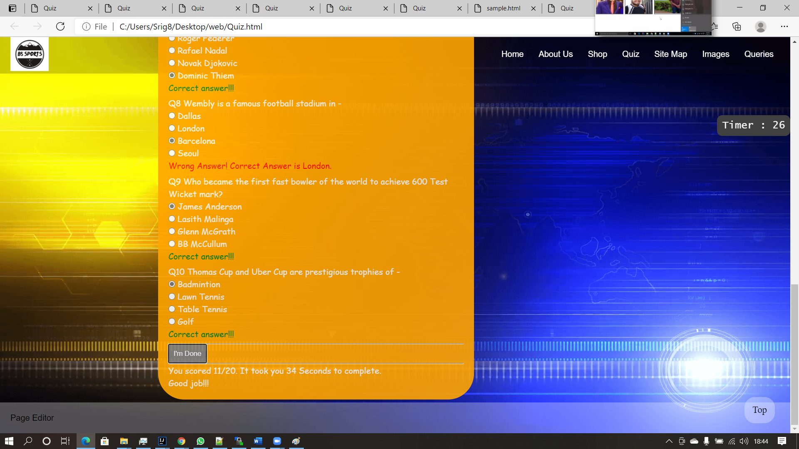

FileName : AboutUs

Screenshot

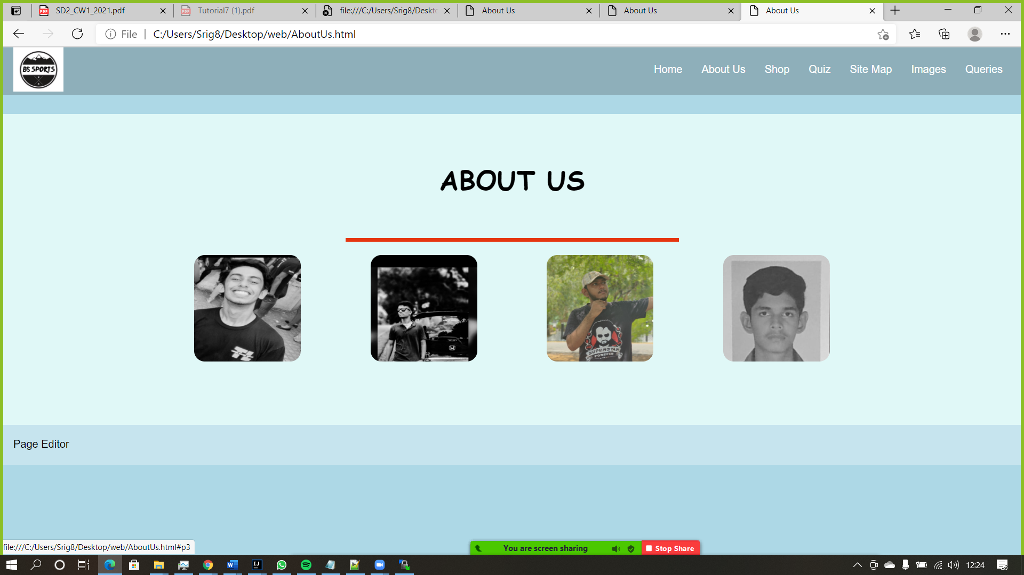

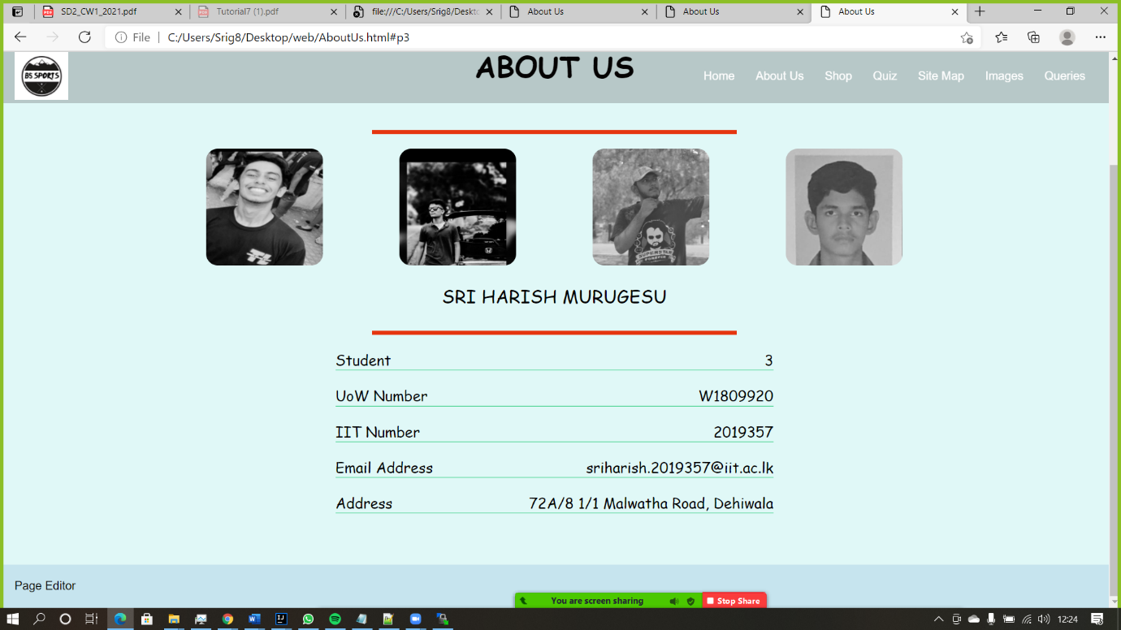

## Appendix C: Individual Statement

|  |  |  |  |
| --- | --- | --- | --- |
| Student Name: | Sri Harish Murugesu | Student Id: | 2019357 |
| State what tasks you carried out in the project. | | | |
| Student 3 I created the quiz and the introduction about the team members and page editor of myself. | | | |
| State what you enjoyed and did not enjoy about teamwork. | | | |
| My team members were helpful in every situation, we help each other in every critical scenario. | | | |
| State what you learnt about teamwork. | | | |
| Team Work is a must when conducting projects. It helps us lessen the burden. | | | |
| State what skills you gained/learnt from undertaking the project. | | | |
| I learnt how html and java script works and got to know about my team mates well. | | | |
| State any strengths about yourself that emerged whilst undertaking the project. | | | |
| The strength I got is handling the time well. | | | |
| State any weaknesses about yourself that emerged whilst undertaking the project. | | | |
| I was stressing myself, straining to find out and implement the codes. | | | |
| State how you would do things better if you were to undertake the project again. | | | |
| I would directly guide myself and my team members to finish the hard tasks first so that the time duration will be more than enough to complete others tasks for me and my team members in the future. | | | |
| Additional general or project specific comments: | | | |
| Nothing specific about projects, but if the management could give one assignment at a time, it would be easy for us to manage our workload. Many of us stressed out because of tutorials submission and some of the batch people are unable to do the assignment because of this, please do read my statement and help us in the future. Thank you. | | | |
| Student Signature: | SriHarish.M | Date: | 23/03/2021 |